**VENKATESH**

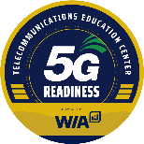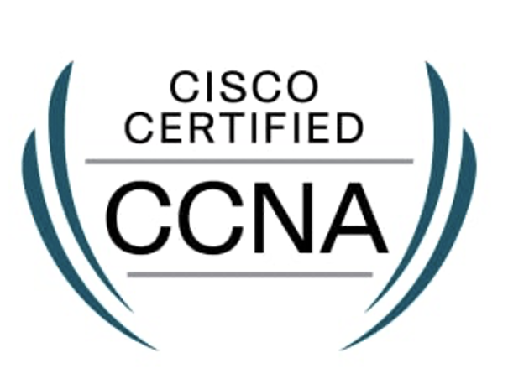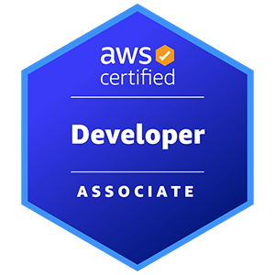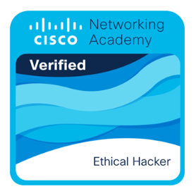

**SUMMARY:**

* **Certified Network Engineer** with **5 years** of experience in in designing, deploying, and managing enterprise network infrastructure, security operations, and large-scale DNS management (Infoblox, BIND, Cloudflare DNS).
* Extensive experience in DNS administration, troubleshooting, and optimization, ensuring 99.9% uptime and 35% reduction in resolution latency for enterprise environments.
* Skilled in **DNS (Infoblox), network automation, firewall security, VPN solutions, SD-WAN, and enterprise network monitoring**.
* Expertise in **TCP/IP protocols, packet analysis (Wireshark, Splunk), Grafana visualization, and network troubleshooting**.
* Hands-on expertise in firewalls (Palo Alto, Cisco ASA, Fortinet), VPN (IPsec, SSL, DMVPN), IDS/IPS, Zero Trust security architecture, and role-based access control (RBAC) for secure remote access.
* Implemented Splunk log analysis, Grafana dashboards, and NetFlow monitoring, improving threat detection and reducing downtime by 30%.
* Strong proficiency in **BGP, OSPF, EIGRP, MPLS, VLAN segmentation, STP**, optimizing traffic routing and improving bandwidth utilization by 25%.
* Deployed and managed AWS Direct Connect, Transit Gateway, VPC Peering, Azure ExpressRoute, integrating on-prem and cloud networks seamlessly.
* Automated network deployments using Ansible, Terraform, Python (Netmiko, Napalm), reducing manual configurations by 50% and improving efficiency.
* Designed and optimized SD-WAN (Cisco Viptela, Meraki, Silver Peak) solutions, improving redundancy and scalability across multi-site enterprise networks.
* Ensured 100% compliance with security standards, maintaining ITIL-based change management processes for network modifications and security hardening.
* CCNA, AWS Certified Developer – Associate, CEH (Cisco), Infoblox Core DDI (In Progress), WIA 5G Wireless Readiness, demonstrating commitment to professional development.

**TECHNICAL SKILLS:**

|  |  |
| --- | --- |
| **Enterprise Networking and Protocols** | Cisco Routing & Switching, LAN/WAN, SD-WAN (Cisco Viptela, Meraki, Silver Peak), MPLS, VPN (IPsec, SSL, DMVPN), VLANs, STP, BGP, OSPF, EIGRP, QoS, IPv4/IPv6. |
| **Network Security and Access Control** | Firewalls (Cisco ASA, Palo Alto Networks, Fortinet, Check  Point, Juniper SRX,), IDS/IPS (Snort, Suricata), ACLs, VPN Security, Zero Trust Architecture, RADIUS, TACACS+ |
| **Network Monitoring and Troubleshooting** | Packet Analysis (Wireshark, TCPDump), Performance Monitoring (SolarWinds, NetFlow, PRTG, Nagios, LogicMonitor, ThousandEyes), Network Analytics (Cisco DNA Center, Splunk). |
| **Cloud & Virtual Networking** | AWS (VPC, Transit Gateway, Direct Connect, Route 53, Security Groups), Azure (NSG, VNet, ExpressRoute, Azure Firewall). |
| **Automation & Infrastructure as Code (IaC)** | Configuration Management (Ansible, Terraform, Cisco Prime  Infrastructure), Scripting (Python – Netmiko, Napalm, Paramiko), REST APIs, Bash, PowerShell, JSON, YAML. |
| **Wireless Networking & Mobility** | Wireless LAN (Cisco Meraki, Aruba Wireless, Ruckus,  Ubiquiti), Wireless Security (WPA2, WPA3, 802.1X, RADIUS). |
| **Configuration Management** | Version Control (Git, GitLab), Network Documentation  (NetBox, Visio, Lucidchart), Change Management (ServiceNow ITSM, ITIL Framework). |

**EDUCATION:**

* Master of Science in Computing and Information Systems from Youngstown State University, OH.

**CERTIFICATIONS:**

* Cisco Certified Network Associate (CCNA)
* Certified Ethical Hacker (CEH) – Cisco
* AWS Certified Developer – Associate
* WIA 5G Wireless Readiness

**PROFESSIONAL EXPERIENCE:**

**Catholic Health Initiatives - Houston, TX February 2025 - Till Date**

**Role: Network Engineer**

**Responsibilities:**

* Developed automation scripts using Python and Ansible to streamline DNS record management and reduce manual efforts.
* Integrated Infoblox with Splunk, enabling real-time DNS query logging and security event monitoring.
* Optimized TCP/IP configurations across multiple network environments to reduce packet loss and improve latency.
* Implemented DNSSEC (Domain Name System Security Extensions) to enhance the integrity and security of DNS responses.
* Used Grafana to visualize network health metrics, tracking DNS query loads and system performance trends.
* Deployed high-availability (HA) DNS solutions, ensuring redundancy and failover capabilities for enterprise-critical applications.
* Provided technical support for DNS-related incidents, ensuring minimal downtime.
* Worked on mail server configurations, troubleshooting MX records, SPF, DKIM, and DMARC policies for email security.
* Worked on integrating DNS with cloud environments (AWS, Azure) for hybrid infrastructure.
* Performed deep-dive packet analysis using Wireshark to investigate network anomalies and performance bottlenecks.
* Collaborated with cybersecurity teams to detect and mitigate DNS tunneling and other DNS-based attacks.
* Assisted in capacity planning for DNS servers, ensuring scalability and redundancy.

**Youngstown State University (YSU) – Ohio** **May 2023 - December 2024**

**Role: Network Engineer**

**Responsibilities:**

* Designed, deployed, and managed enterprise network infrastructure, ensuring high availability and 99.9% uptime.
* Administered and maintained DNS (Infoblox), ensuring high-performance and secure name resolution across enterprise networks.
* Analyzed network traffic and DNS logs using Splunk and Grafana, identifying anomalies and optimizing response times.
* Configured over 150 routers, switches, and firewalls, securing enterprise networks against cyber threats.
* Troubleshot and resolved 95% of network incidents within SLA, reducing downtime and improving network reliability.
* Implemented firewall security policies, ACLs, and VPN configurations, ensuring secure connectivity.
* Assisted in network migrations and upgrades, minimizing downtime during transitions.
* Automated network configuration tasks using Python and Ansible, reducing deployment time by 50%.
* Monitored network performance using SolarWinds, NetFlow, and Wireshark, optimizing bandwidth allocation by 25%.
* Created and maintained technical documentation, improving troubleshooting efficiency by 35%.

**Tata Consultancy Services - Bangalore**  **December 2021 - January 2023**

**Role: Network Security Analyst**

**Responsibilities:**

* Designed and optimized LAN/WAN architectures, enhancing network performance and redundancy.
* Deployed and managed firewalls, IDS/IPS, and VPN solutions, strengthening network security posture by 40%.
* Configured and maintained BGP, OSPF, EIGRP, VLANs, and STP, optimizing traffic routing and segmentation.
* Conducted network capacity planning, ensuring efficient resource allocation and reducing bottlenecks by 30%.
* Integrated network monitoring tools (SolarWinds, PRTG, Wireshark), improving issue detection and resolution speed by 45%.
* Implemented wireless networking solutions using Cisco Meraki, Aruba, and Ruckus to enhance enterprise mobility.
* Provided Level 2/3 network support, troubleshooting complex issues and implementing long-term fixes.
* Managed network access control (NAC) solutions, enforcing authentication and authorization policies across the network.
* Supported cloud networking (AWS, Azure, GCP), integrating on-prem and cloud environments, increasing scalability.
* Assisted in network automation initiatives using Ansible, Python, and Terraform, reducing manual configurations by 50%.
* Created and maintained change management and compliance documentation, ensuring audit readiness.
* Collaborated with cybersecurity teams, enforcing security policies and mitigating threat risks by 35%.

**Visual IT Solutions - Hyderabad**  **September 2020 - November 2021**

**Role: Network Administrator**

**Responsibilities:**

* Installed, configured, and maintained network devices, ensuring 99.9% uptime and secure operations.
* Managed user access, VLANs, and firewall rules, enforcing security policies across 100+ network segments.
* Conducted daily network health checks, proactively identifying and resolving potential issues.
* Assisted in patch management and firmware updates, maintaining 100% compliance with security standards.
* Provided technical support for network-related incidents, resolving 90% of issues without escalation.
* Documented network configurations, topologies, and troubleshooting steps for future reference.
* Configured and managed DHCP, DNS, and IPAM, ensuring seamless connectivity.
* Monitored bandwidth utilization and network performance, optimizing traffic flow and reducing congestion by 25%.
* Implemented network security measures, preventing unauthorized access and reducing security incidents.
* Assisted in network expansion projects, ensuring proper planning and smooth implementation.